1. **SORTING QUERIES**

* **Find top 5 Samsung phones with biggest screen size**

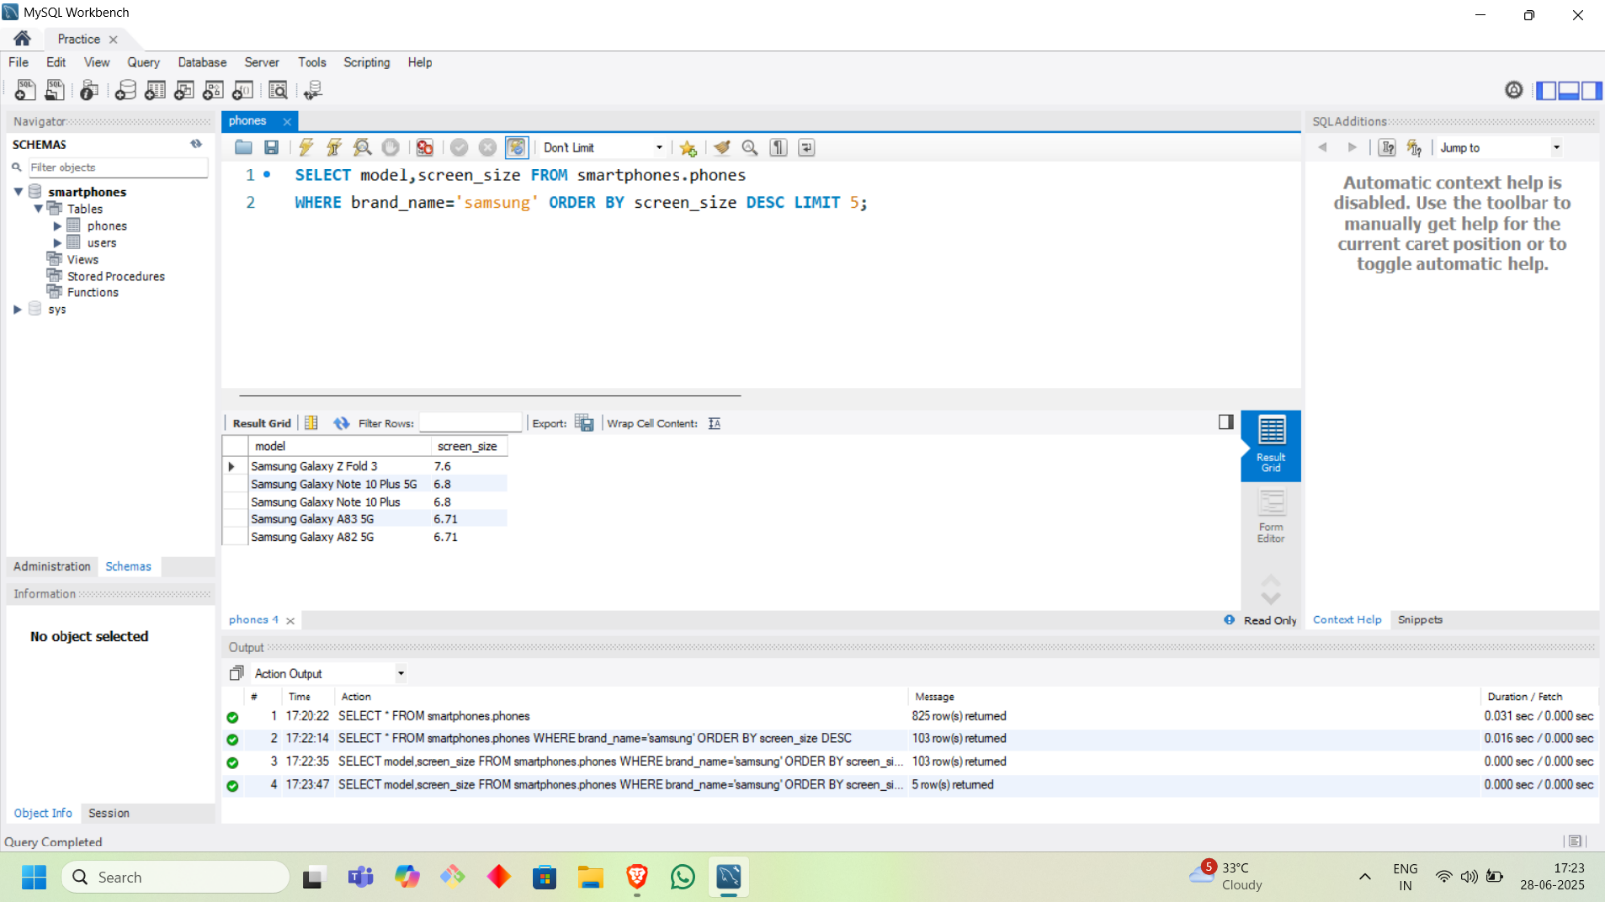

* **Sort all the phone in descending order of number of total cameras**

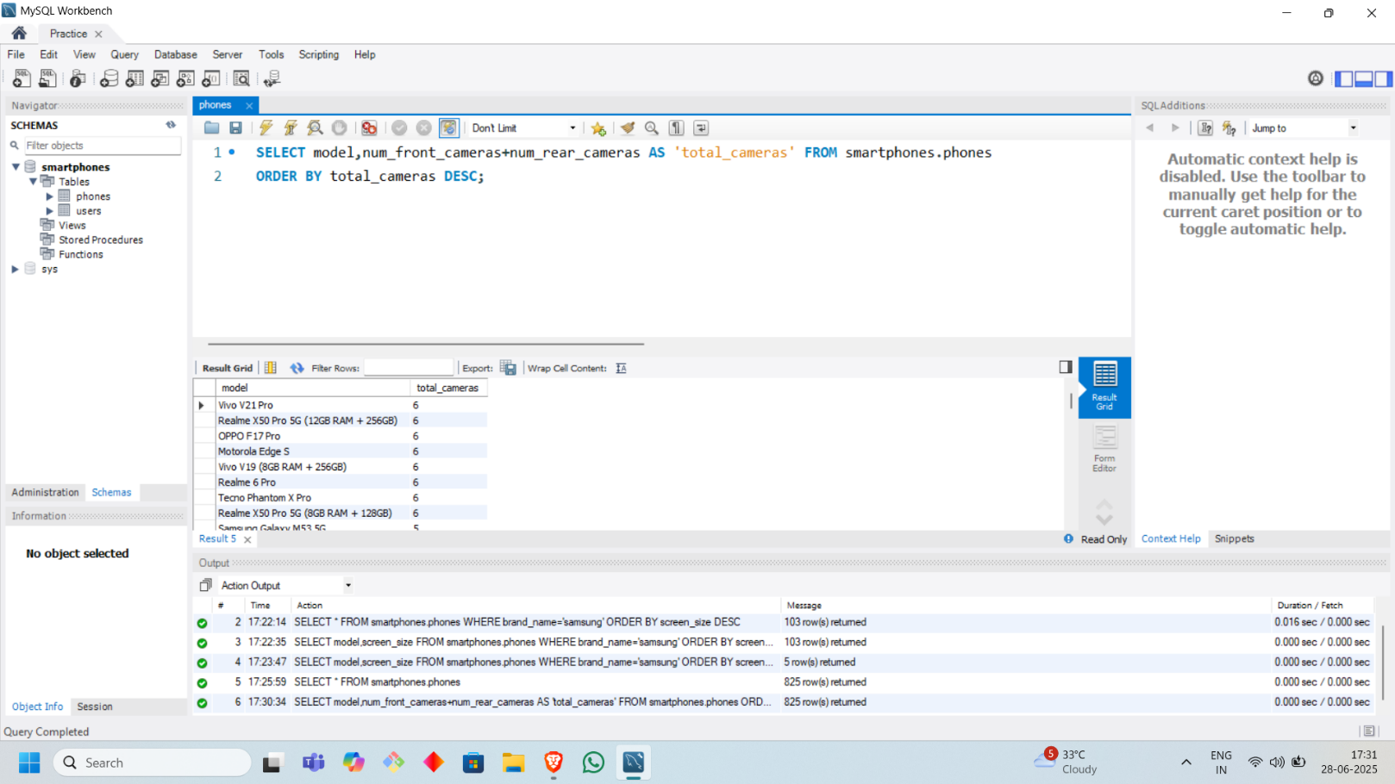

* **Sort data on the basis of PPI (Pixels Per Inch) in decreasing order**

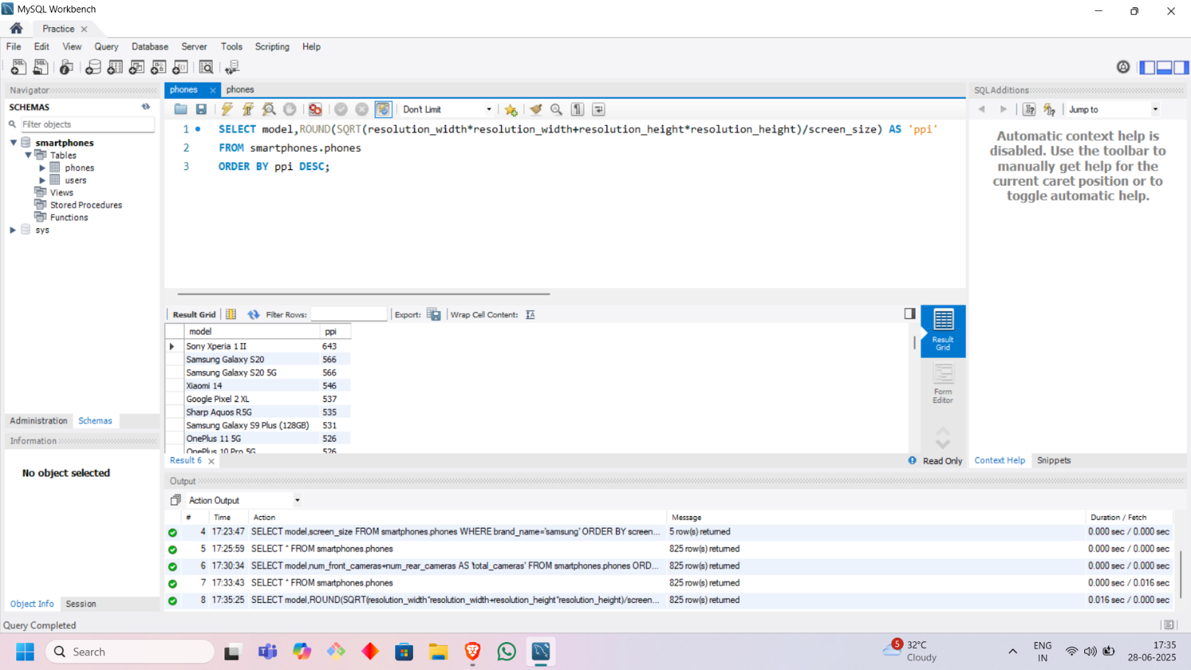

* **Find the phone with 2nd Largest battery**

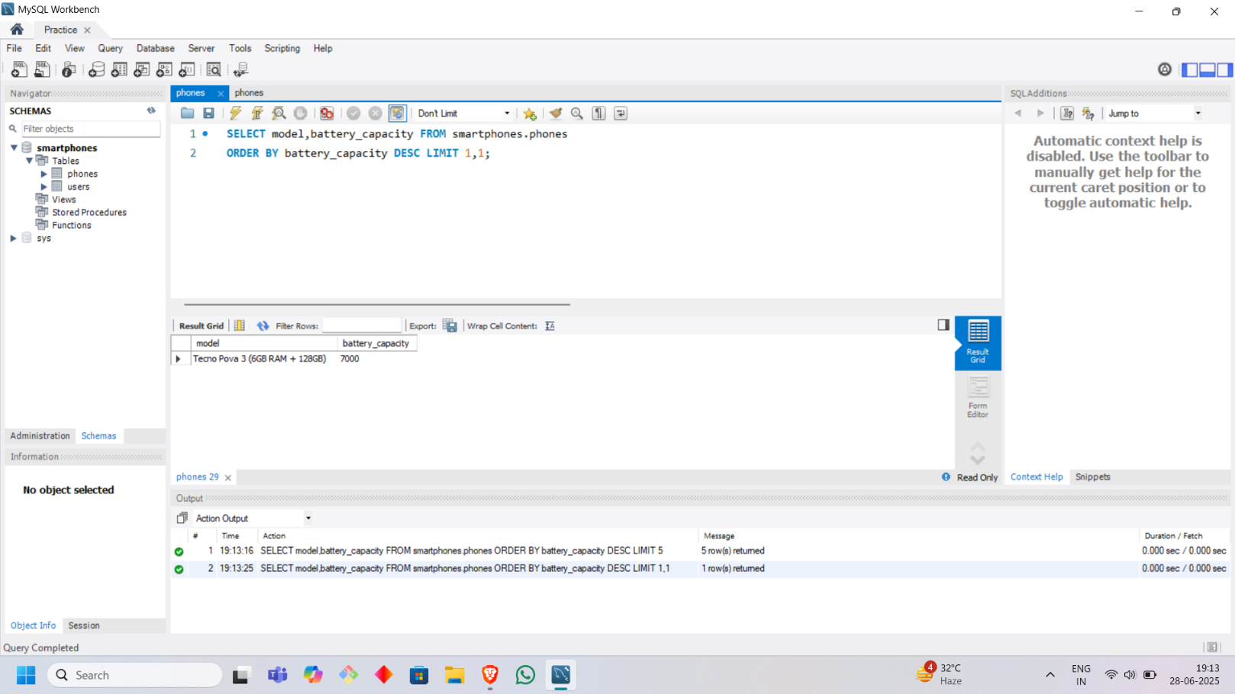

* **Find the name and rating of the worst rated apple phone**

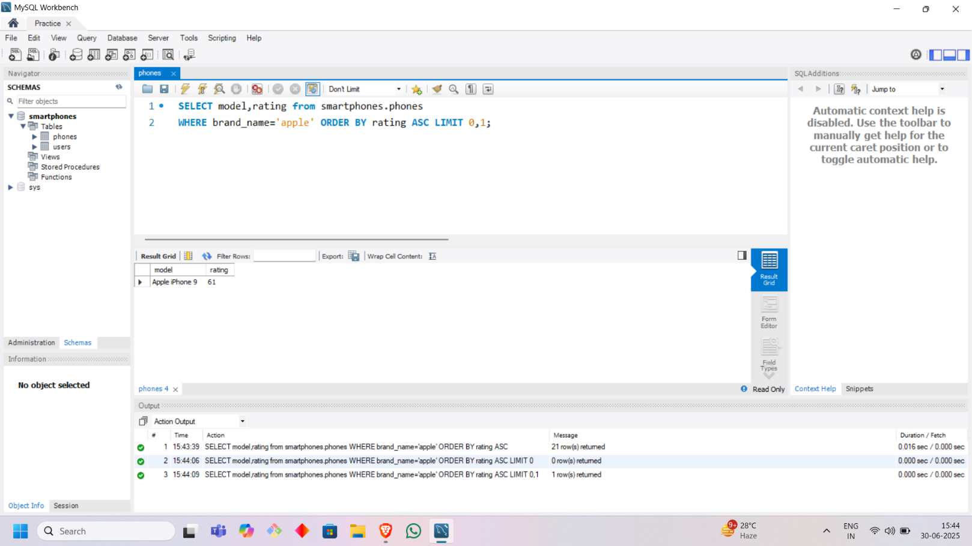

* **Sort phones alphabetically and then on the basis of rating in descending order**

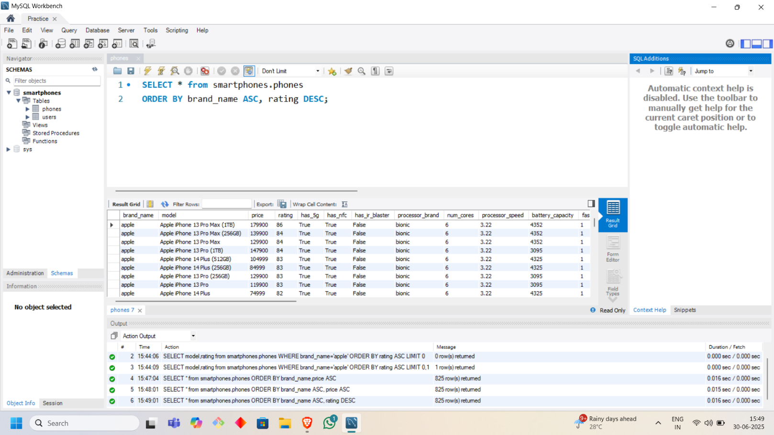

* **Sort phones alphabetically and then on basis of price in ascending order**

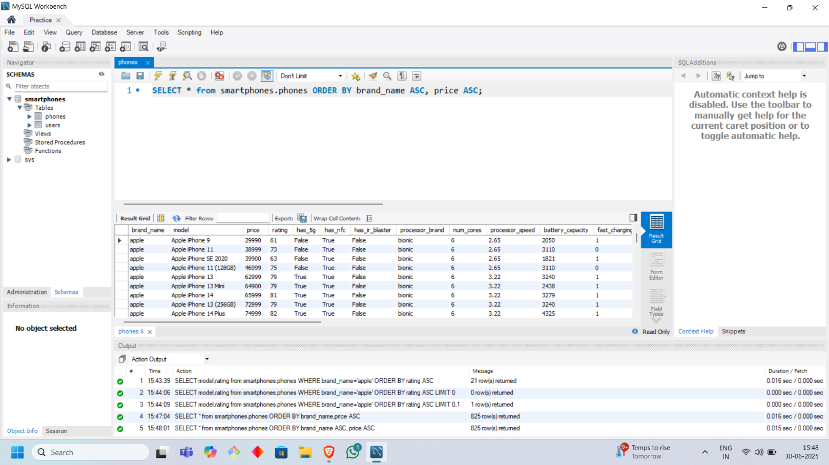

1. **GROUPING QUERIES**

* **Group smartphones by brand and get the count, average price, max rating, average screen size, average battery capacity**

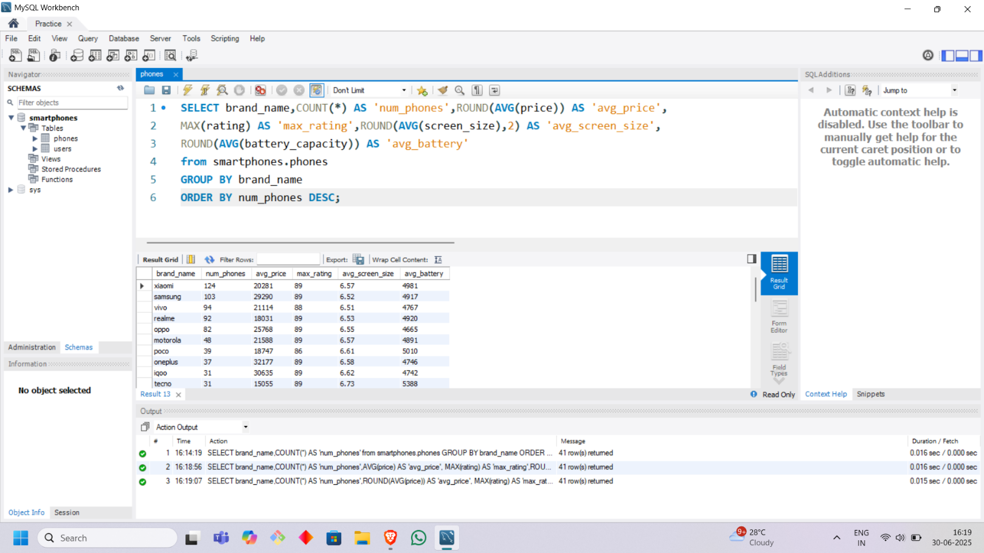

* **Group smartphones by whether they have an NFC and get the average price and rating**

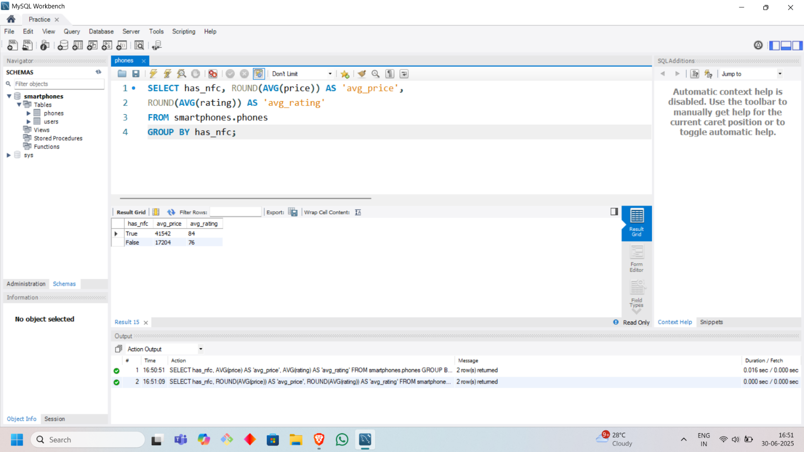

* **Group smartphones by the extended memory available and get the average price**

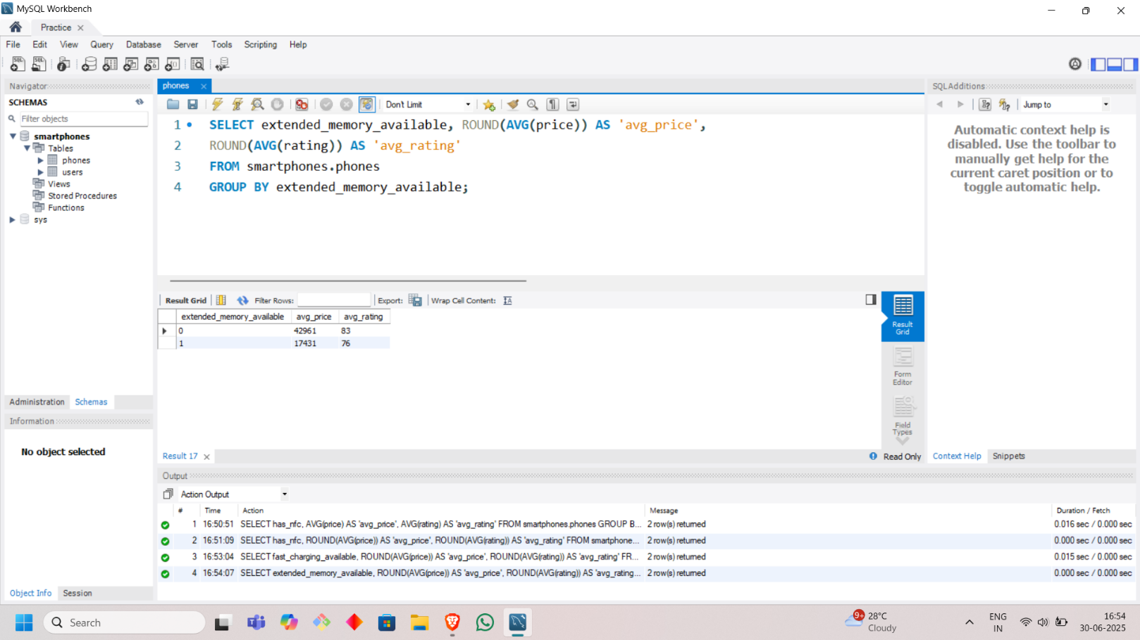

* **Group smartphones by brand and processor brand and get the count of models and the average primary camera resolution (rear)**

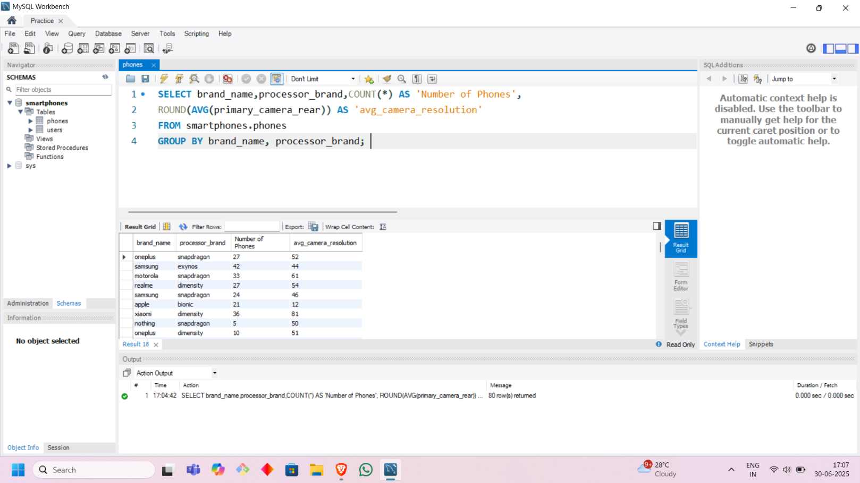

* **Find Top 5 most costly phone brands**

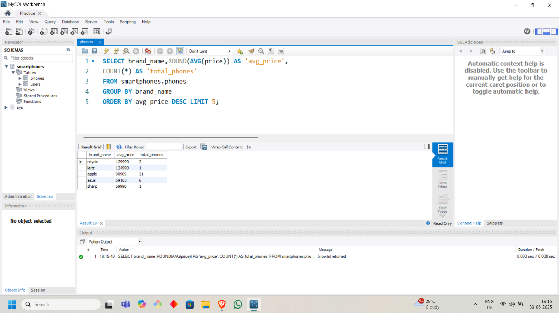

* **Which brand makes the smallest screen smartphones**

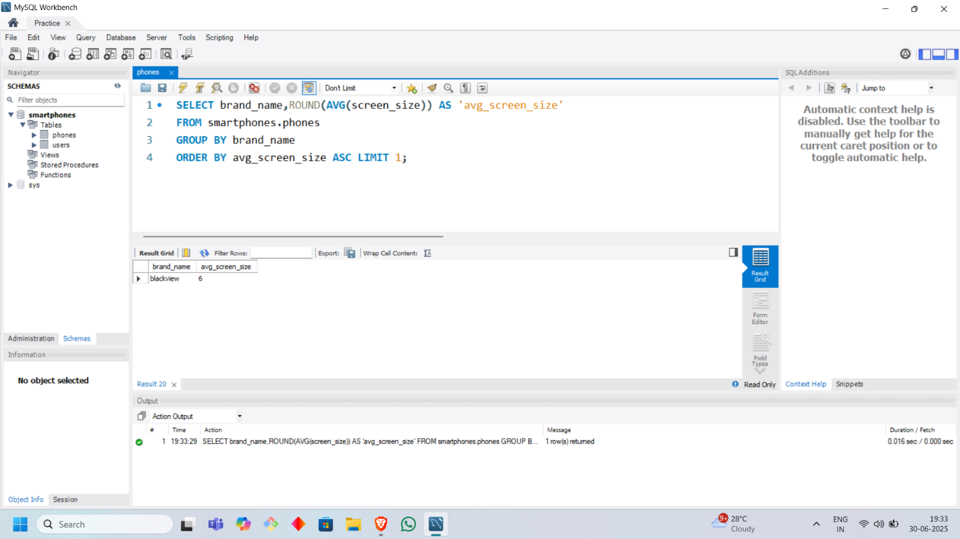

* **Group smartphones by the brand and find the brand with the highest number of models that have both NFC and an IR blaster**

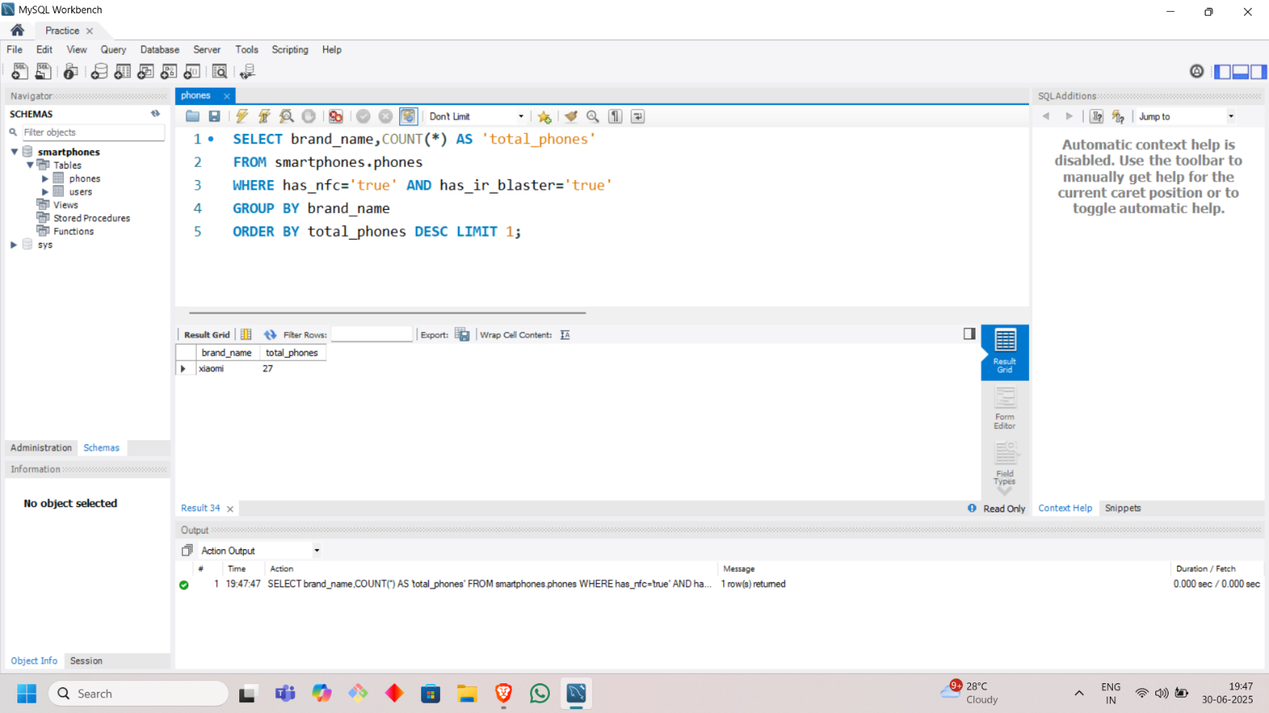

* **Find all the Samsung 5g enabled smartphones and find out the average price for NFC and Non-NFC phones**

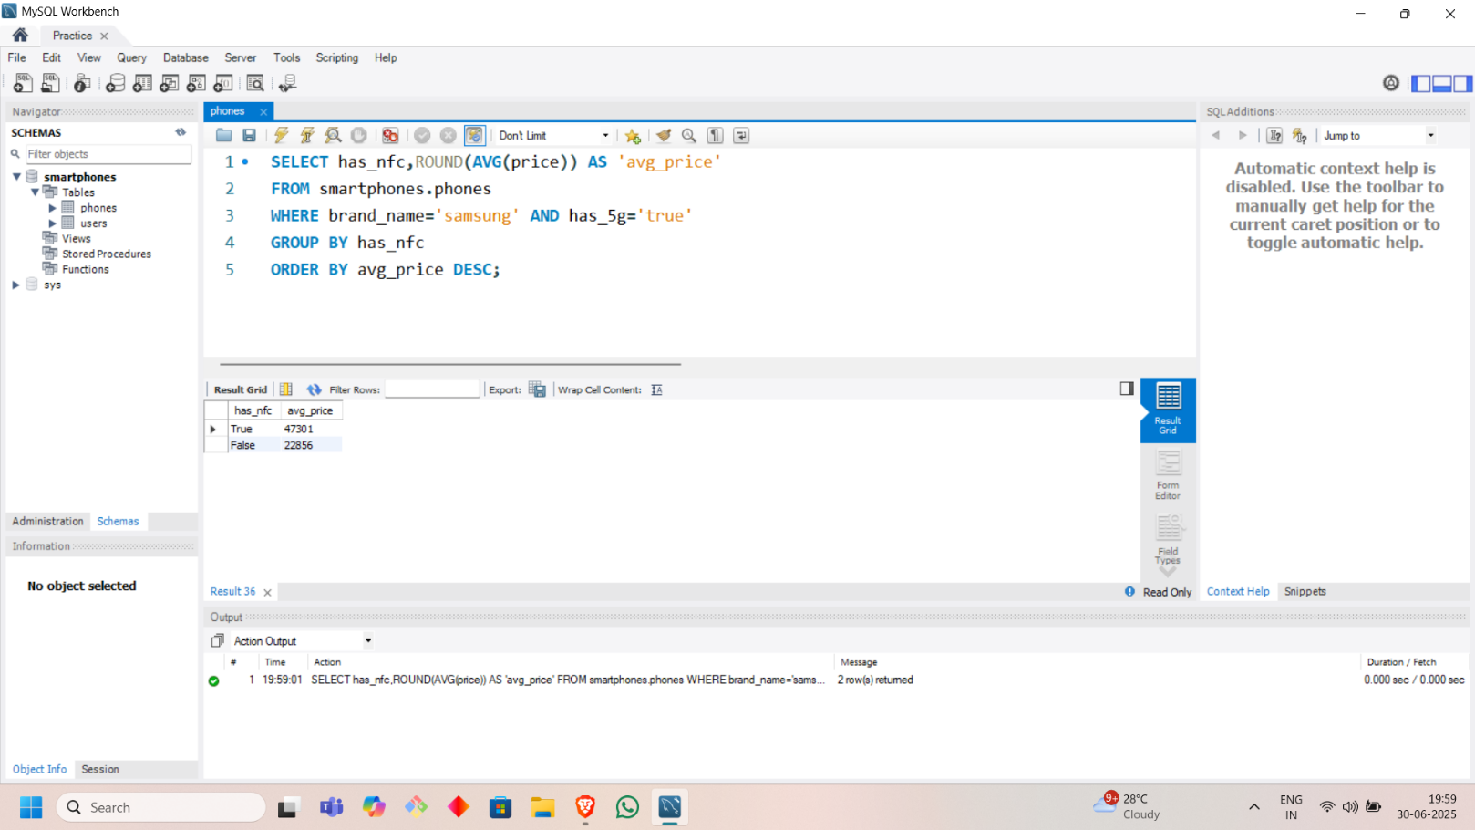

1. **HAVING QUERIES**

* **Find the average rating of smartphone brands which have more than 20 phones**

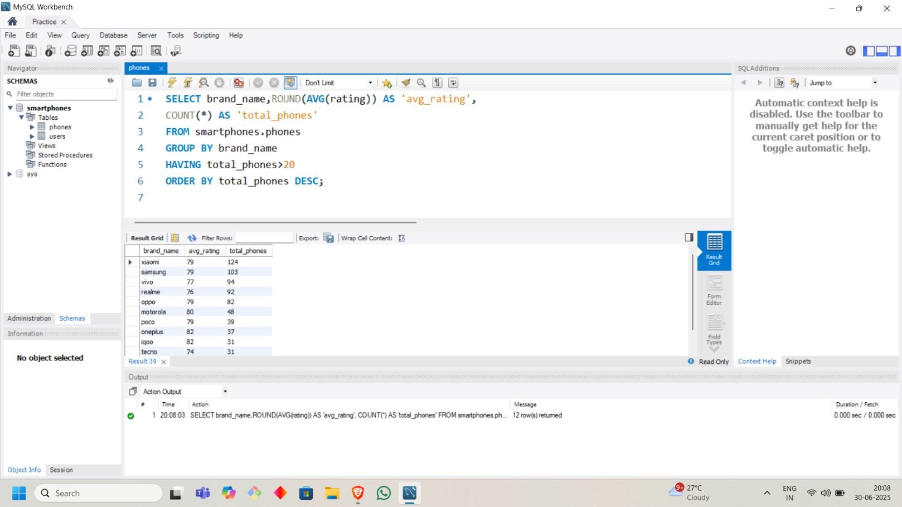

* **Find the Top 3 brands with the highest average ram that have a refresh rate of at least 90 Hz and fast charging available and don’t consider brands which have less than 10 phones**

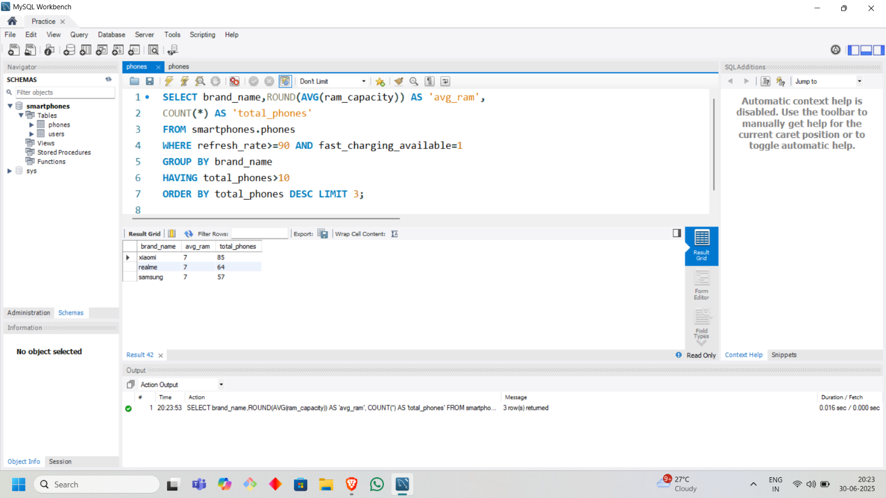

* **Find the average price of all the phone brands with average rating > 70 and num_phones more than 10 among all 5g enabled phones**

